Choose a website that evokes a certain “look and feel”:

The website I chose is the website of WIX:

<https://www.wix.com/website-template/view/html/2187>

The website evokes me of a feeling of “Clean” and here is my reason.

1. Balance: The website is using the asymmetrical balance as well as symmetrical balance, except for the part below, all other parts are symmetrical balance so that the style gives me a feeling that it is complete and Succinct.

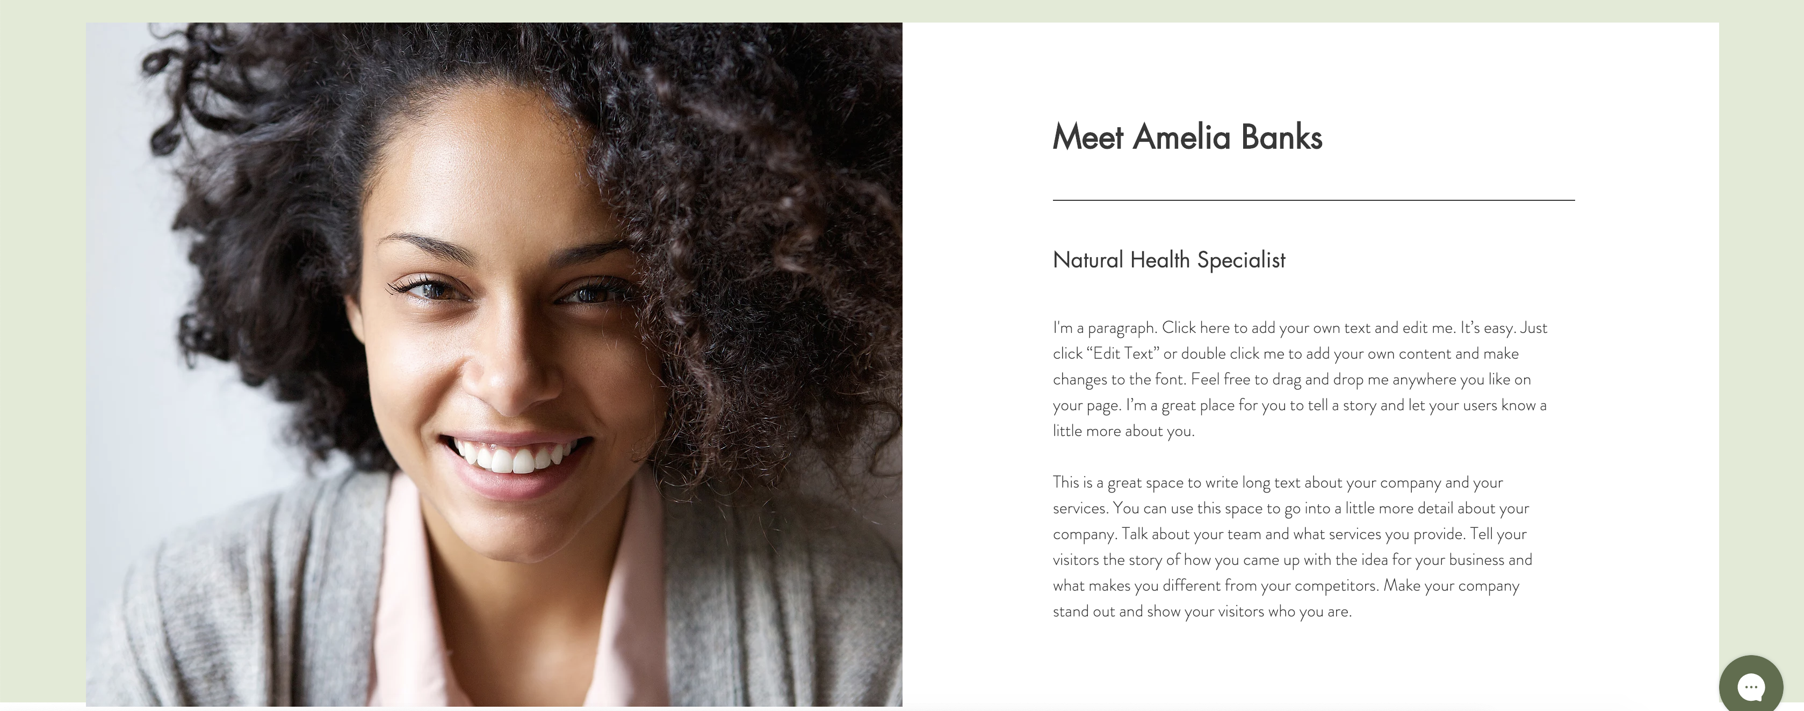

1. Contrast: The color of white and black gives me a feeling that the website is very professional and can help me solve my problem, so I am willing to see and read the contents of the WIX website.
2. Emphasis: Every website has some functions or points to emphasize on. So is the WIX website, it has a big picture at the first glance as below:

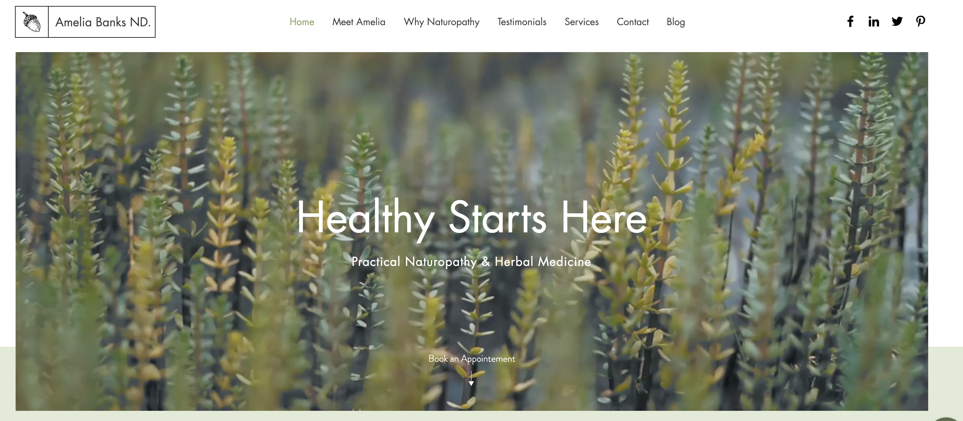

And there is a center-white-font, so everyone who logs in the website will notice the word “Healthy Starts Here” and get to know what the website is for.

1. Movement: Thera are ways of adding movements into your website and WIX uses a picture of wind-blowing wheat and it enables us to think about food and health, also the green and yellow colors are very good and easy-looking so it shows the “clean” of the website.
2. Repetition: Repeating the same element again and again creates a pattern that is satisfactory to the eye. In the website, all its parts are likely the same, so it will not distract the visitors and make them wondering “what does this different part mean？”That is why it can give me a feeling of “clean”
3. Hierarchy: Great composition splits elements into three levels of hierarchy: the most important, the middle stuff, and the least important. The website has the most important one the picture with “healthy starts here”, the middle stuff services and introduction part and the least important one contraction and address part.
4. Unity : The website’s elements has a harmonious feeling, whether the green-white-black colors or the layout of every parts gives me a unified feeling of clean and professional, so the visitors has the interest to stay on the website and learn more.